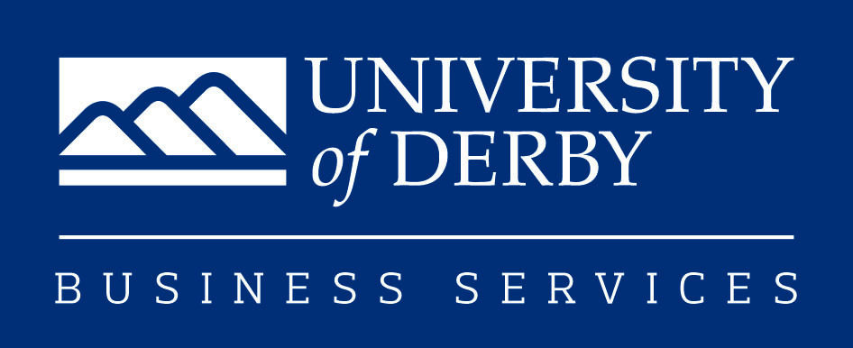

BANKS MILL STUDIOS AFFILIATE MEMBERSHIP
APPLICATION FORM

Your contact details:

Name: _________________________________________________________________________________

Address: _______________________________________________________________________________

___________________________________________________ Post Code: _________________________

Home Tel: ______________________________________________________________________________

Mobile Tel: _____________________________________________________________________________

Business Tel: ___________________________________________________________________________

Email: _________________________________________________________________________________

Website: _______________________________________________________________________________

Twitter Name:___________________________________________________________________________

Facebook page:_________________________________________________________________________

Instagram: _____________________________________________________________________________

Linked-in Profile:_________________________________________________________________________

Please indicate how you came to know about Banks Mill Affiliate Services at the University of Derby:

_______________________________________________________________________________________

Affiliate Services Package (£50 plus VAT per annum):

- Opportunity to submit work for Banks Mill Exhibitions and events including our annual Open Studios Event (additional participation fees apply)
- Your business and news stories promoted through our social media networks
- Emailed opportunities regarding exhibitions and events organised by Banks Mill and external organisations
- Invites to exhibition opportunities meetings
- Discount on workshop space (T&Cs apply)
- Free use of the Banks Mill foyer for solo exhibitions (Ts&Cs apply)

Total amount payable to end of current year:_________£______________________________

Educational background:

What is your highest level qualification? _______________________________________________________

Where are you studying/did you study & what year will you/did you graduate?__________________________

_______________________________________________________________________________________

About your business/practice:

Please describe your business idea/practice: ___________________________________________________

_______________________________________________________________________________________

_______________________________________________________________________________________
(attach additional sheets as necessary)

What is the current status of your business (ie considering/currently setting up/early stages of business etc)?

_______________________________________________________________________________________

If you have set up a business, give date of establishment: _________________________________________

Name of business: ________________________________________________________________________

Are you a sole trader/limited company? ________________________________________________________

From where are you currently working? ________________________________________________________

Would you be interested in a studio in the future?______________________________________________

PLEASE BE SURE TO INCLUDE THE FOLLOWING WITH YOUR APPLICATION

- A brief overview/visuals of your work (these will be returned if you enclose a stamped addressed envelope).
- Any other relevant information, e.g. CV, in support of your application.

Declaration:
I have read and accept the terms and conditions of Banks Mill Affiliate Services

Signed: ………………………………………………………………. Date: ………………………………………

Please return your completed application to:

Business Incubation Coordinator
Banks Mill Studios
71 Bridge Street
Derby
DE1 3LB

Or email it to banksmill@derby.ac.uk

