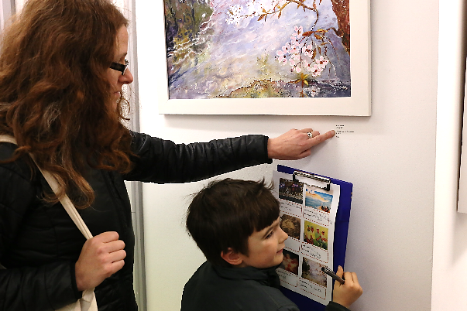
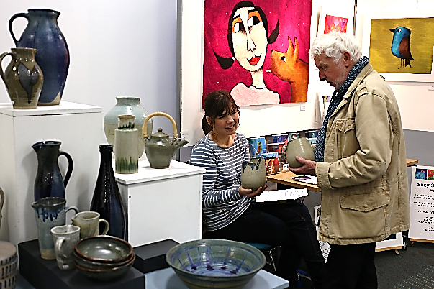
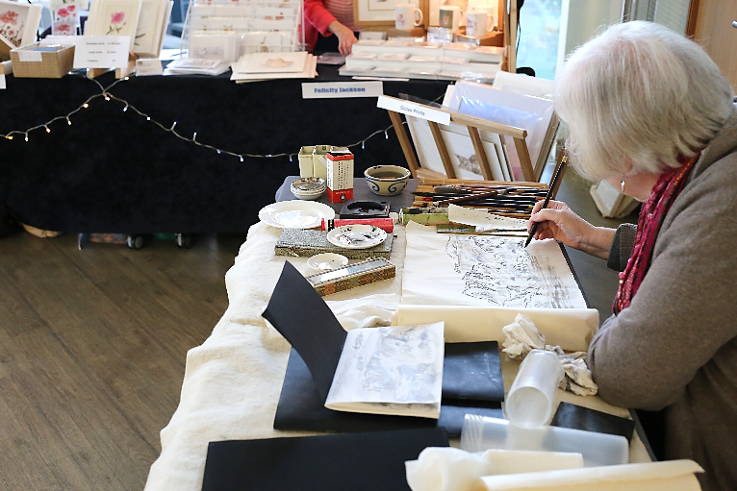

BANKS MILL OPEN STUDIOS 2017
ARTISAN FAIR APPLICATION PACK

Banks Mill Open Studios and Artisan Fair:
Fri, 24 Nov 5pm-8pm; Sat & Sun, 25 & 26 Nov 10am-5pm

Banks Mill Open Studios was launched in 2004 to provide a platform for our residents to exhibit their work. Since its small beginnings our Open Studios has grown significantly with the introduction of our Artisan Fair and is now regarded as a prestigious event within the creative community and showcases and celebrates work from artists, designers and makers from across Derbyshire and beyond.
Applications are now being invited to affiliate and non-members of Banks Mill for stalls at our Artisan Fair which is being held at the Enterprise Centre, a state of the art conference venue located just west of Derby city centre on Bridge Street. We have secured the prestigious Conservatory area for our stall holders, along with further large conference rooms on the first floor.

This is a fantastic opportunity to showcase your work at this highly popular event with visitor numbers reaching well over 1,400 throughout the weekend. For the second year running we are also very pleased to be working in partnership with the Peak District Artisans, this will enable us to attract more visitors throughout Derbyshire, rather than just Derby and its suburbs.

Booking Details

Applications are invited from artists, makers and food producers who hand make their own work in the following disciplines (other areas will also be considered):

- Art & Illustration
- Ceramics & Pottery
- Creative Workshops
- Glass
- Felt Making
- Fine Art
- Leatherwork
- Metalwork
- Jewellery
- Mixed Media
- Photography
- Printmaking
- Sculpture
- Speciality Food
- Stationery/Cards
- Textiles
- Weaving
- Wood Craft

Completed applications should to be emailed to banksmill@derby.ac.uk or posted to:
Open Studios Co-ordinator
Banks Mill Studios
71 Bridge Street
Derby, DE1 3LB

*Please note that if your application is received after 30 September we will unfortunately be unable to include your details within the event brochure; however we will still be able to include your details in our social media activity.

Please include all relevant information with your application form along with visuals of what you intend to sell at the fair. If your application is successful a non-refundable deposit (50% of your total fee) is then required to secure your place, with the balance becoming due by 1 October.

The event is promoted through flyer distribution in the local area, articles in the local press, magazine features, website listings and pushed through social media. However; we also encourage all participants to share the event information via their website, social media and by distributing invites at events they are attending.

Entry Fee:
Affiliate Members: Trestle table (140cm x 60cm) £45 (inc VAT) extra tables at £10 each
Affiliate members can also submit 2D and 3D artwork to be displayed at Banks Mill

Non-members: Trestle table (140cm x 60cm) £80 (inc VAT) extra tables at £15 each
Floor space only (140cm) £80 (inc VAT) extra space at £15 per 140cm

Up to 40 exhibitors will be selected for the event. There will also be a reserve list in operation.

Set-Up and Take-Down:
The Enterprise Centre will be ready for set-up on Friday afternoon, 24 November (time to be confirmed, usually mid-day). All stall holders need to be set-up and ready by 4.45pm on Friday evening.

Take down is from 5pm on Sunday and all stall holders need to vacate the building by 7pm on Sunday, 26 November.
For further information regarding the Artisan Fair or applications please contact the team on 01332 – 597866 or email banksmill@derby.ac.uk

APPLICATION FORM

Please complete this form in block capitals. If your application is successful the details you supply in section one will be used for your brochure entry so please ensure these are correct (address details will not be printed).

Please read the guidelines and terms and conditions carefully and ensure all requested information is provided. Please also include up to six large resolution images of the work which you intend to sell (include one each of landscape and portrait orientation) - at least 300dpi in size for printing purposes. These can be emailed to banksmill@derby.ac.uk or included within your application on a clearly labelled CD. Please note these images may also be used for other marketing purposes.

SECTION ONE:

Name: ___________________________________________________________________________

Company Name: ___________________________________________________________________

Address: __________________________________________________________________________

___________________________________________ Postcode: ______________________________

Company Tel: _______________________________ Mobile: _______________________________

Email: ____________________________________________________________________________

Website: __________________________________________________________________________

*Facebook: ________________________________________________________________________

*Twitter: __________________________________________________________________________

*Instagram: ________________________________________________________________________
*Please note that these will be printed space permitting so please indicate (1, 2, 3) as to the importance of each social media channel to your business

Area of specialism/describe discipline (no more than five words): __________________________

__________________________________________________________________________________

SECTION TWO:

Brief description of work to be exhibited (no more than 100 words):

__________________________________________________________________________________

__________________________________________________________________________________

__________________________________________________________________________________

SECTION THREE:

Image One Title: ___________________________________________________________________
(Preferred brochure entry image; must be of landscape orientation at 300 dpi)

Image Two Title: ___________________________________________________________________

Image Three Title: __________________________________________________________________

Image Four Title: ___________________________________________________________________

Image Five Title: ___________________________________________________________________

Image Six Title: ____________________________________________________________________

Do you need access to an electrical socket?: _____________________________________________

Do you wish to hire additional tables?: ________________________________________________

Do you wish to hire table cloths at £2 per table: _________________________________________

Please tell us how you heard about our Artisan Fair:

__________________________________________________________________________________

__________________________________________________________________________________

PLEASE ENSURE YOU SEND US A COPY OF YOUR PUBLIC LIABILITY INSURANCE ALONG WITH YOUR APPLICATION

For official use only:

Date Application Received
Application approved/rejected
Images Received
Deposit Payment Received & Amount
Balance Received
Additional Tables Booked
Table cloth hired
Socket Required
PLI Provided

TERMS & CONDITIONS

- Exhibitors will need to ensure that all items are adequately insured for transit and whilst on University of Derby property.

- The University of Derby cannot be held responsible for any loss, damage or stolen items, or accidents occurring during the event.

- All electrical equipment bought in must be PAT tested including extension cables. One 13 amp socket will be available if requested on the application form.

- Public liability insurance is mandatory and a valid certificate must be provided along with your application.

- Once stands/stalls are ready exhibitors need to complete a visual inspection of their area and ensure all hazards are removed.

- No lit flames/candles or any other smoke emitting devices are permitted within the Enterprise Centre.

- On arrival please familiarise yourself with the fire exit procedure and the nearest exit.

- Any table cloths hired out must be returned to a member of staff on Sunday, failure to do this will result in a charge for a replacement table cloth.

- All accidents, incidents and near misses that occur on site must be reported to a member of staff immediately.

- Wall fixings are not permitted within the centre; exhibition boards, if required, need to be supplied by the exhibitor.

- Exhibitors are required to be ready fifteen minutes prior to opening and be present for the whole duration of the event. Exhibitors must not close their stand before closing time.

- Unfortunately we are unable to allow alcohol onto the premises during the event.

- Flyers will be made available to exhibitors prior to the event for distribution.

- All images for marketing purposes and directory/brochure inclusion details need to be submitted with your application.

- Exhibitors are invited to attend organisation meetings prior to the event.

- Exhibitors are encouraged to volunteer to help with promoting the event, both prior to and during the event.

- A non-refundable deposit is required (50% of your total fee) to secure your entry, failure to make this payment may result in your stand being reallocated. The final balance payment is due by 1 October. Unfortunately stand fees cannot be refunded after this date.

- Banks Mill reserve the right to withdraw and reallocate stands which are not paid for by the specified dates, no refunds will be given in these circumstances.

- If The University of Derby are forced to cancel the event the exhibitor fee will be refunded in full, however The University of Derby cannot be held liable for any additional expenses incurred.

- By submitting an application to the Artisan Fair you consent to these terms and conditions and that the information provided in your application, including images may be used for marketing purposes.

ADDITIONAL INFORMATION
Please find below additional information which you might find useful.

Where should I park?
Unfortunately onsite car parking is reserved for visitors; however space for loading and unloading will be available. Limited parking spaces may be available at Nunnery Court – please contact the team for more details.

What times can I access the building?
Stall set up is usually from 12pm. The Enterprise Centre will be open from 9am on Saturday and Sunday.

How long have I got to clear my stall on Sunday?
All stalls should be packed up by 7pm when the building closes.

Will there be wifi available?
The signal within the Enterprise Centre cannot be guaranteed and codes for wifi access will be issued by reception each day, we recommend you check and test portable machines before the event.

Is there a cash dispenser in the building?
No, the nearest cash dispenser to signpost your visitors to is at Sainsbury’s on Mill Street, about a minutes’ walk from the Enterprise Centre or at the Co-op petrol station, Duffield Road.

Will there be refreshments and food to purchase?
Food can be purchased at the Enterprise Centre from Costa (limited opening hours) along with hot and cold drinks, or alternatively Sainsbury’s local on the corner of Mill Street or Number 67 Bridge Street café/bar.

Should I bring an extension lead and lighting?
If you have requested access to an electrical outlet please ensure you bring your own PAT tested extension lead as only one socket may be available. You will need to supply your own lighting for your stall, should you require this and this needs to be PAT tested.

Should I bring table coverings, props, display stands?
Yes, all exhibitors must bring their own as these cannot be provided. The only storage space available will be under your table; therefore we recommend you bring a table covering that will reach the floor to disguise this, or alternatively hire table cloths at £2 each.

Where will my stand be?
All stands will be located on the first floor and allocated in advance prior to your arrival and labelled clearly. There are various areas available within the Enterprise Centre for stalls and these will be allocated based on the number of applications received.

Are there first aid facilities?
First aid facilities are available on site in the event of an emergency. Please contact a member of staff if first aid attention is required.

What is the fire and emergency policy?
Upon hearing the fire alarm you must evacuate the building by the nearest exit and make your way to the fire assembly point within the car park.

If you find or suspect a fire, raise the alarm by pressing the alarm button at fire points. You should not attempt to re-enter the building until advised it is safe to do so.

EVENT CONTACTS:

Laura Williams
Banks Mill Manager
01332 – 597848
07767 – 352885
l.k.williams@derby.ac.uk

Karen Holland
Open Studios & Artisan Fair Co-ordinator
01332 - 594170
k.holland@derby.ac.uk

Michele Walker
Open Studios & Artisan Fair Co-ordinator
01332 – 597829
m.walker1@derby.ac.uk

Thank you for your application, we look forward to seeing you at the Artisan Fair and wish you a successful event

